Practical - 11
Practical Title: Student Management CRUD with Search and Filter
Create a student management module to add, view, edit, delete, search and filter student records. All database operations must use MYSQLi statements and clear success/failure messages.

Theory:
- Are SELECT, INSERT, UPDATE, and DELETE operations working?
Yes, all CRUD operations are working correctly. SELECT displays student records, INSERT adds new students, UPDATE modifies student details, and DELETE removes student records.
- Is search by name/email/course implemented?
Yes, search by student name, email, and course is implemented. The course filter also displays students from the selected course.
- Are delete operations confirmed before execution?
Yes, a confirmation message appears before deleting a student record. The record is deleted only after clicking OK.

Implementation
PHP Functions and MySQLi Methods Used
Function / Method Purpose
new mysqli() Connects PHP to MySQL.
prepare() Prepares an SQL statement. bind_param() Binds values to query parameters. execute() Executes the SQL statement.
get_result() Retrieves query results. fetch_assoc() Fetches a row as an associative array.
trim() Removes extra whitespace from input. htmlspecialchars() Helps safely display user-provided text. confirm() Asks for confirmation before deletion.
isset() Checks whether a variable or form value exists.

Code Purpose
$conn = new mysqli(...) Connects PHP to MySQL INSERT INTO Adds a new student
SELECT Retrieves student records
UPDATE Modifies student information DELETE FROM Removes a student
$conn->prepare() Prepares an SQL statement safely bind_param() Binds values to the query parameters LIKE Searches for matching text
LIMIT and OFFSET Display records page by page confirm() Asks the user before deletion
htmlspecialchars() Helps prevent HTML/script injection when displaying data filter_var() Validates the email format

Evidence of Work (Screenshots)
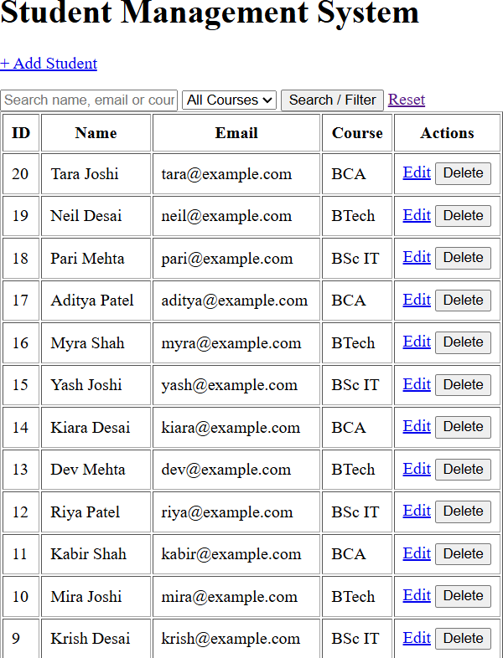

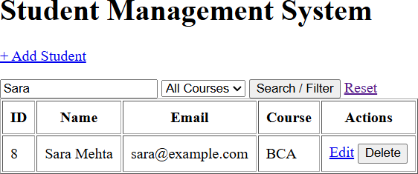

- GitHub Repository Link: https://github.com/shahmahi0717/Student-Hub-Portal

- Challenges Faced:
- Performing INSERT, SELECT, UPDATE, and DELETE operations correctly.
- Implementing search by name, email, and course.
- Displaying proper success and error messages.

Learning Outcomes:
- Understood how to perform CRUD operations on student records.
- Learned to search students by name, email, and course.
- Understood how to filter records based on the selected course.

Faculty Remarks:



